Assignment
Excel

Question 1. What is the difference between 'Paste' and 'Paste Special' in Excel? Briefly explain with examples.
Answer. Paste (Ctrl+V): In Excel copies everything—values, formulas, and formatting—from a cell. '
It replicates the entire copied content, including formulas, formatting (colors, fonts, borders), and comments.
Example: Copy a cell with the formula =A1+B1 and a blue background. Pasting it will paste the formula and the blue background into the new cell, with the formula adjusting its cell references (e.g., to =C1+D1).

Paste Special (Ctrl+Alt+V): It offers granular control, letting you paste only specific elements like values (to remove formulas), formats, or even perform mathematical operations, giving you precision over the copied data's final appearance and function.
It opens a dialog box to choose specific attributes to paste, like values only (to remove formulas), formats only, or to transpose data.

Example 1 (Values Only): Copy a cell with =$A$1*2. Paste Special > Values will paste the result (e.g., 10), not the formula, making the data static.
Example 2 (Formats Only): Copy a cell with bold, green text. Paste Special > Formats will apply only the bold, green formatting to the destination cell, leaving its original value and formulas untouched.

The key difference between paste and paste special is that the paste command allows the user to insert the selected data from the clipboard into an application while the paste special command follows the same functionality similar to paste, but provides additional options to select how the inserted data should appear on the application.

Question 2. Describe the functions and usefulness of 'Freeze Panes' and 'Split Panes' in Excel.
Answer. Freeze Panes is a feature in Excel that allows you to lock specific rows or columns in place so they remain visible while you scroll through the rest of the worksheet. This is particularly useful when working with large datasets, as it helps you keep important headers, labels, or identifiers in view while analyzing the data below or to the side.
- Freezing the Top Row: Keeps the first row visible, usually used for column headers.
- Freezing the First Column: Locks the first column in place, often used for row labels or identifiers.
- Custom Freeze Panes: Allows you to freeze multiple rows and/or columns based on your selection.
Splitting Panes in Excel means breaking a workbook into different parts. This technique is available in the "View" tab's "Windows" section. We can split panes horizontally or vertically, or it can be a cross split. The horizontal and vertical split can be seen in the mid-section of the worksheet. However, we can do a cross split by dragging the panes.
It is useful for comparing far-apart data, maintaining header visibility while scrolling, and reviewing data without constant navigation.
Question 3. Explain the difference between inserting a new row and inserting a new column in Excel. Can you insert multiple rows or columns at once?
Answer. The key difference between columns and rows is that a column arranges data vertically from top to bottom, while a row arranges data horizontally from left to right. Rows and columns are different based on how they align data. Rows and columns are common concepts in computer science and data analytics.
Rows are identified by numbers, while columns are labeled by letters.

Yes, we can insert multiple rows or columns at once.

Question 4. What are logical functions in Excel? Provide examples of at least two logical functions and their applications.
Answer. Logical functions in Excel are tools used to evaluate specific conditions and return a result, TRUE or FALSE based on whether those conditions are met. They act as decision-making tools, allowing you to perform different calculations or display different values depending on your data.

Core Logical Functions
- IF: The most common logical function. It checks a condition and returns one value if the condition is TRUE and another if it is FALSE.
- AND: Returns TRUE only if all arguments are true.
- OR: Returns TRUE if at least one argument is true.
- NOT: Reverses the logic of its argument (changes TRUE to FALSE and vice versa).
- XOR: Returns TRUE if an odd number of arguments are true (exclusive OR).
Example 1: IF: Inventory Alerts
A retail store manager can automatically flag items for restock when quantities are low.
Formula: =IF(B2<50, "Reorder", "In Stock")
Real-Life Context: If you have 40 shirts left, Excel displays "Reorder" so you never run out of stock.

Example 2: AND: High-Performance Sales Bonuses
A finance leader can use this to identify employees who qualify for a bonus by meeting two strict goals.
Formula: =IF(AND(B2>10000, C2="Sales"), B2*0.05, 0)
Real-Life Context: This ensures a 5% commission is only paid if the employee is in the Sales department and their sales exceed Rs.10,000.

Question 5.Discuss the purpose of 'XLOOKUP' and how it differs from the traditional 'VLOOKUP' function.
Answer. XLOOKUP is a modern, versatile Excel function designed to find specific data in a table or range, acting as a superior successor to VLOOKUP and HLOOKUP.
Unlike these traditional functions, XLOOKUP can search both vertically and horizontally, making it ideal for retrieving specific values from any range in a table. With added benefits like default exact matching and the ability to handle errors more gracefully, XLOOKUP makes data retrieval in Excel easier and more reliable.

Question 6.Create a worksheet titled 'Employee Data' with columns: Name, Age, Department. Add 5 rows of data.
Format as follows:
● Bold and center-align the header row
● Apply a fill color
● Auto-fit column width
Answer. Before- 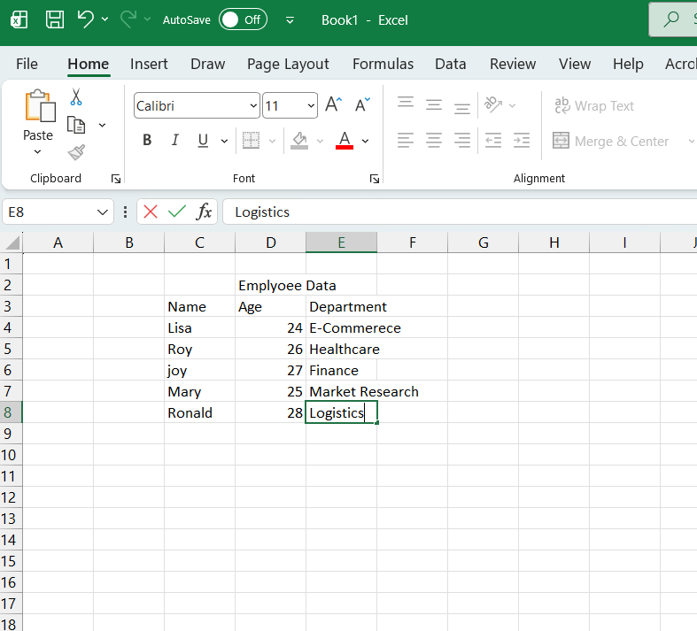
After - 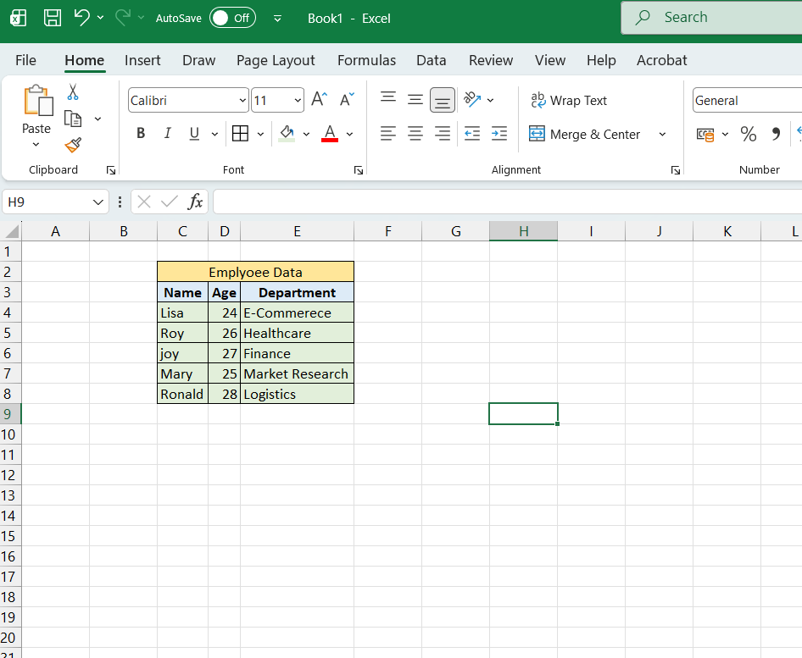

Question 7. Demonstrate how to insert and delete multiple rows and columns in Excel.
Answer.
Before - 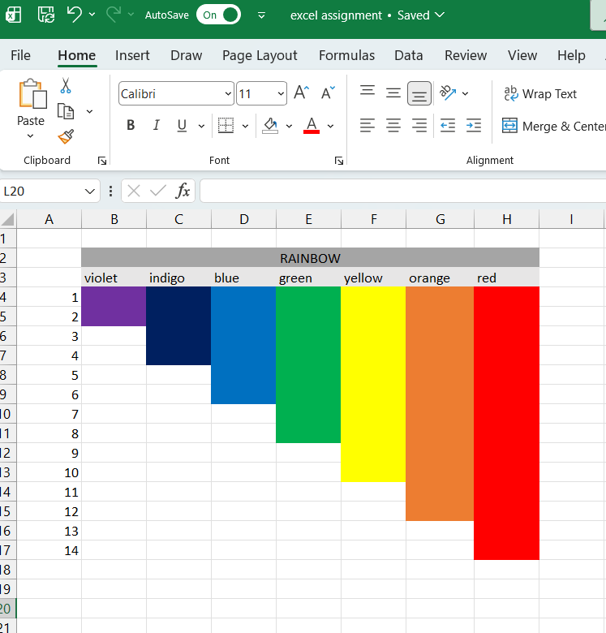

Demonstration of inserting multiple rows:
After - 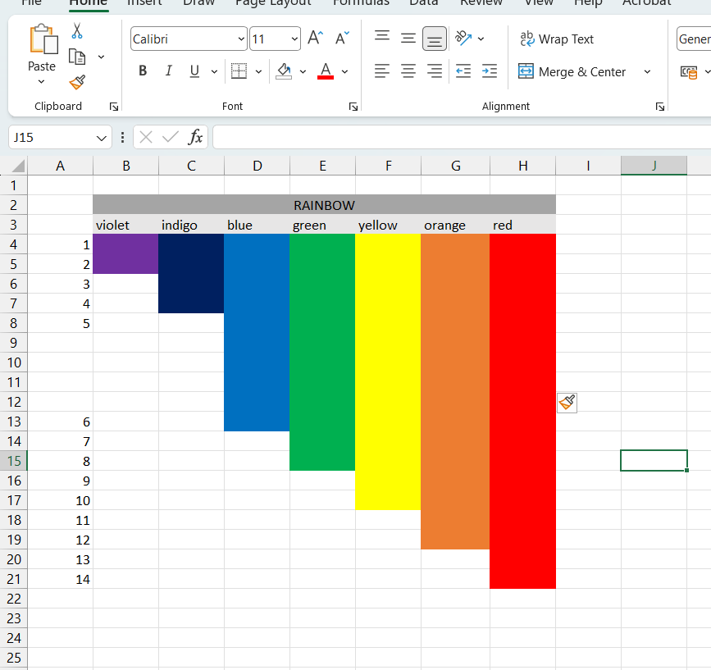

Demonstration of inserting multiple columns:
After - 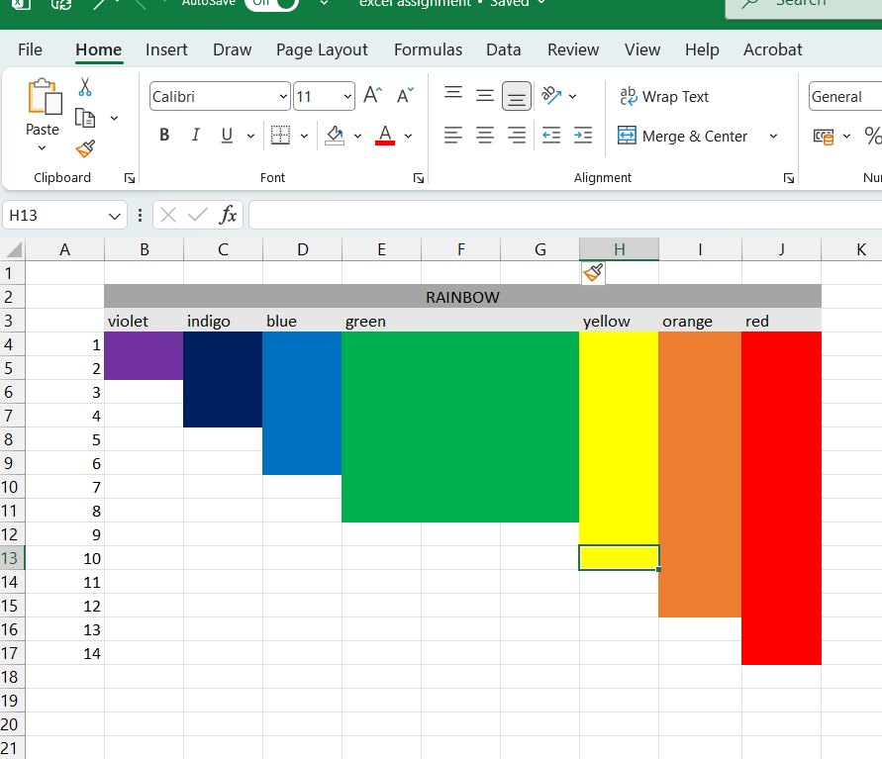
Demonstration of deleting multiple rows:
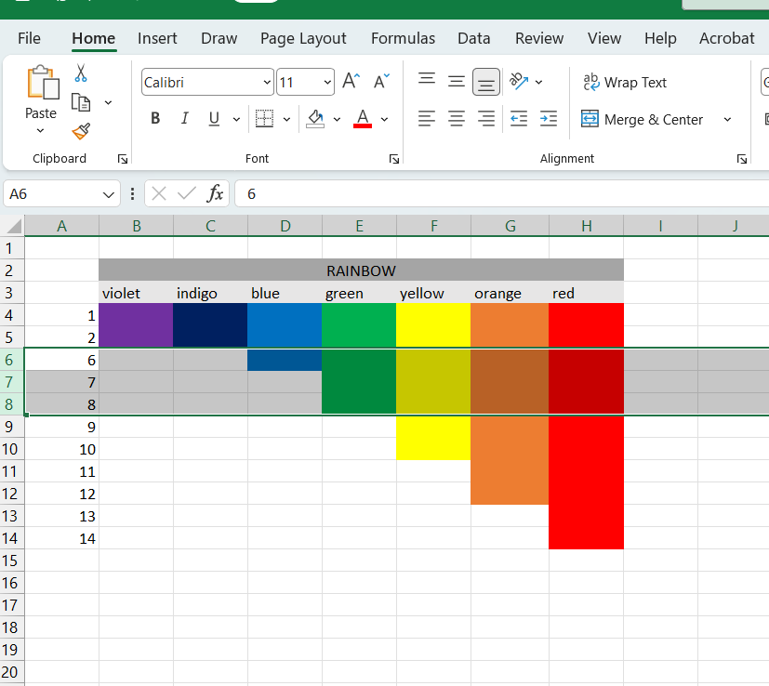
Demonstration of deleting multiple columns:
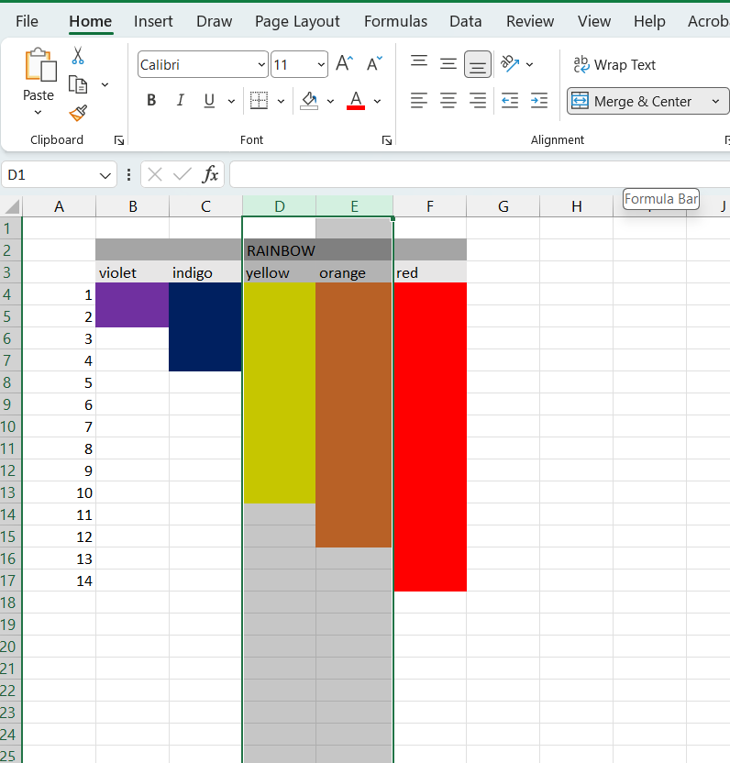

Question 8: Use Excel's 'Find and Replace' feature to update department names in a sample table.
Answer. Ctrl + H (shortcut for Find and Replace).

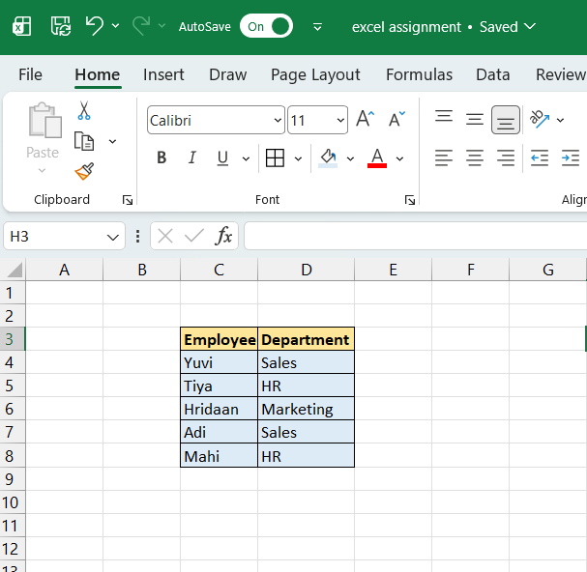

Updated Table (After replacing HR with Human Resources):
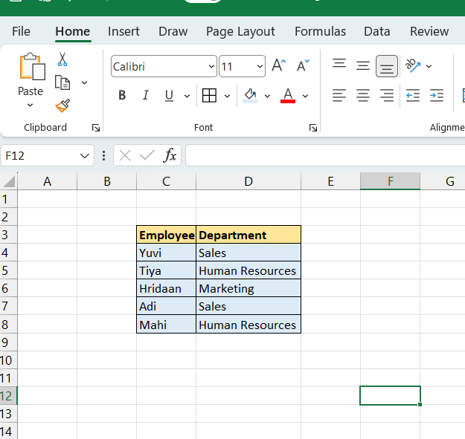

Question 9: Create a small numerical dataset and apply the following functions:
● AVERAGE ● MAX ● MIN
Answer.
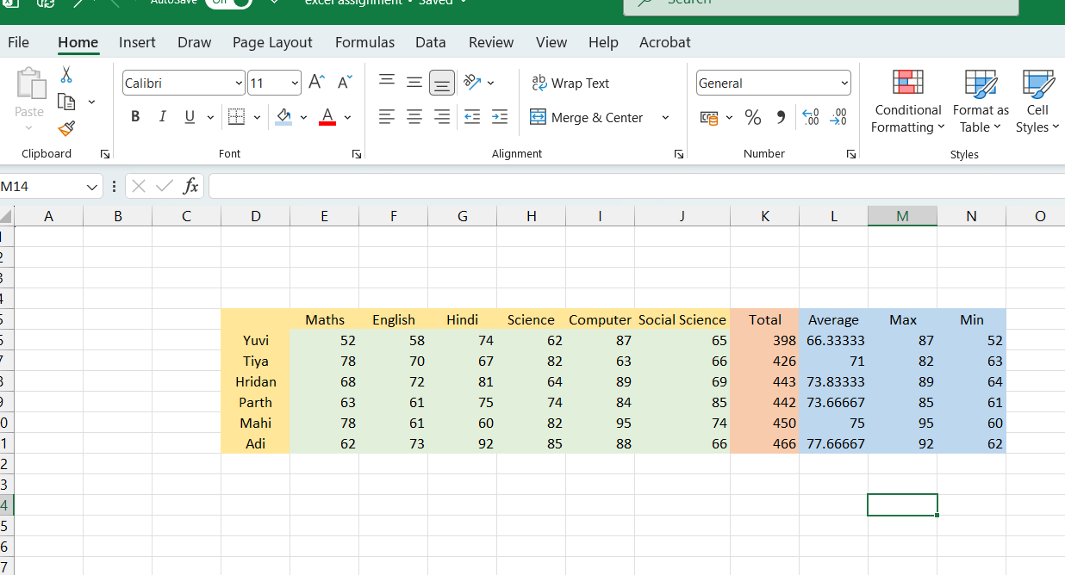

Question 10: You're working with a dataset that contains missing values. As a Data Scientist, explain how you'd detect and handle missing data using Excel.
Mention tools like:
● Go To Special
● ISBLANK
● COUNTBLANK
Answer. Detecting Missing Data in Excel :

1. Go To Special
- Home > Find & Select > Go To Special.
- Choose Blanks → Excel highlights all empty cells in the selected range.
- This is useful for quickly spotting gaps in large datasets and deciding whether to fill, delete, or replace them.

2. ISBLANK Function
- Formula: =ISBLANK(A2)
- Returns TRUE if the cell is empty, FALSE otherwise.
- Helpful for flagging missing values in a new column, so you can filter or apply conditional formatting.

3. COUNTBLANK Function
- Formula: =COUNTBLANK(A1:A100)
- Counts the number of blank cells in a range.
- Useful for quantifying missing data and assessing its impact on analysis.

Handling Missing Data :
- Delete Rows/Columns: If missing values are few and random, you can remove them using filters or Go To Special.
- Imputation:
  - Replace blanks with mean, median, or mode values.
  - Use Excel’s Fill Down/Fill Series for structured replacements.
- Flagging: Create a helper column with ISBLANK to mark missing entries for further review.
- Conditional Formatting: Highlight blanks to visually track missing data patterns.

Example Workflow :
- Use COUNTBLANK to see how many missing values exist.
- Apply Go To Special → Blanks to highlight them.
- Insert a helper column with =ISBLANK(cell) to flag missing entries.
- Decide whether to delete, impute, or leave them depending on the dataset’s context.

